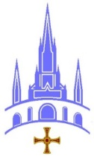
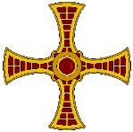
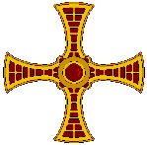
Lourdes Pilgrimage: Uniform Order Form

All helpers will be expected to wear a white polo shirt/ tee shirt, navy trousers (navy crops, or long shorts are also acceptable). A maroon neck scarf will be provided on first day of service whilst in Lourdes. Could male helpers please bring with them a white shirt and tie for the Blessed Sacrament Procession.

It is the responsibility of helpers to provide their own uniform.

To place an order please use the form below. Enclose a cheque made payable to: ‘Lourdes Hospitalité Fund’ and post to … Clothing Order, Lourdes Pilgrimage Office, St. Robert’s Presbytery, Oldgate, Morpeth, Northumberland. NE61 1QF.

Please Note: Nurses should NOT use this form but should contact Mrs Kath McTernan about Polo Shirts because Nurses Polo Shirts are BLUE! And these Polo Shirts are all White.

Men’s Polo Shirts with Youth Logo £16.00
Size |  | S | M | L | XL | 2XL
To fit chest |  | 38” | 40” | 42-44” | 46” | 48”

Men’s Polo Shirts with Hospitalite Logo £16.00
Size |  | S | M | L | XL | 2XL
To fit chest |  | 38” | 40” | 42-44” | 46” | 48”

Ladies Polo Shirts with Youth logo £16.00
Size | XS  (8) | S  (10) | M  (12) | L  (14) | XL  (16) | 2XL  (18) | 3XL  (20) | 4XL  (22)
To fit bust | 30” | 32” | 34” | 36” | 38” | 40” | 42” | 44”

Ladies Polo Shirts with Hospitalite logo £16.00
Size | XS  (8) | S  (10) | M  (12) | L  (14) | XL  (16) | 2XL  (18) | 3XL  (20) | 4XL  (22)
To fit bust | 30” | 32” | 34” | 36” | 38” | 40” | 42” | 44”

Unisex Hoodies ( Maroon with Hospitalite logo) £23.00
Size |  | S | M | L | XL | 2XL
To fit chest |  | 38” | 40” | 42-44” | 46” | 48”

Total order cost |  | £
Name
Tel. Number

Deadline for ordering is Monday 4th June 2018

