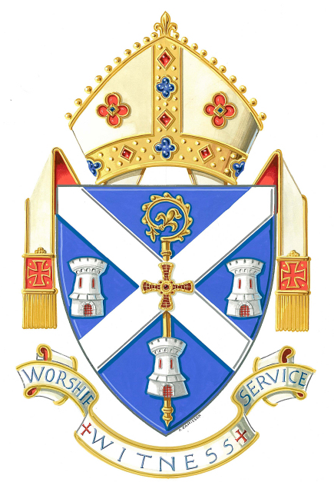
Hexham and Newcastle
Diocesan Pilgrimage to Lourdes
Adult Helpers Registration Form 2017

THIS FORM MUST BE RETURNED BY SUNDAY 11th JUNE 2017
T:o Lourdes Pilgrimage Office, St Robert’s Presbytery, Oldgate, Morpeth, Northumberland NE61 1QF
Your Personal Details (ALL BLOCK LETTERS PLASE)
Name |  | Date of Birth
Address |  | How long at this address?
 |  | Tel No
 |  | Mobile No
 |  | Email Address
Post Code |  | Your Home Parish
Lourdes Experience
Will this be your first experience as a voluntary helper on the pilgrimage? Yes / No
Please tick…. Are you … Adult Youth □ Adult Helper □ Nurse □ Doctor □
If No please describe your previous experience(s) on the Diocesan Pilgrimage.

Safeguarding and Protection
Are you in possession of a Disclosure & Baring Service Enhanced Disclosure Certificate for PARISH work in the Diocese of Hexham & Newcastle? Yes / No [Please note: the Registered Helper Role for this Pilgrimage to Lourdes will be subject to a satisfactory DBS check]
References: Please provide the names and full postal addresses of two people , not relatives, who would be willing and able to provide a character reference for you. You should have been known to them for at least five years and one should be preferably be your priest or minister.
REFEREE 1 |  | REFEREE 2
Name .....................................................................  Address ....................................................................  ...................................................................................  Post Code ................................................................. |  | Name .....................................................................  Address ...................................................................  .................................................................................  Post Code ................................................................
How Long has this person known you? |  | How Long has this person known you?
In what capacity? |  | In what capacity?
* * PLEASE RETURN THIS FORM WITH 2 CURRENT PASSPORT PHOTOS * *
* ALL REGISTERED HELPERS MUST HAVE A VALID
DIOCESAN “DISCLOSURE AND BARRING SERVICE” ENHANCED DISCLOSURE *

